**CYPRESS INSTALLATION/CONFIGURATION AND WORKAROUND GUIDE:**

**Step 1: Install Cypress**

Navigate to your project directory



Install Cypress as a dev dependency:



**Step 2: Open Cypress**

Open Cypress for the first time:

This will create the cypress directory and cypress.config.js configuration file in your project. The cypress directory will have several subdirectories and example test files.

**Step 3: Write Your First Test**

Create a new test file in the cypress/e2e directory. For example:

Add a basic test to the file like below index.cy.js:

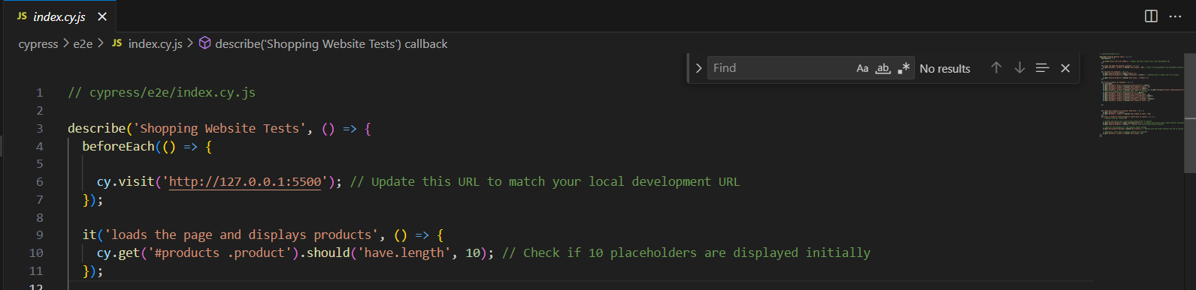

**Step 4: Run Cypress Tests**

Run Cypress tests in the interactive mode:

This will open the Cypress Test Runner where you can run tests interactively.

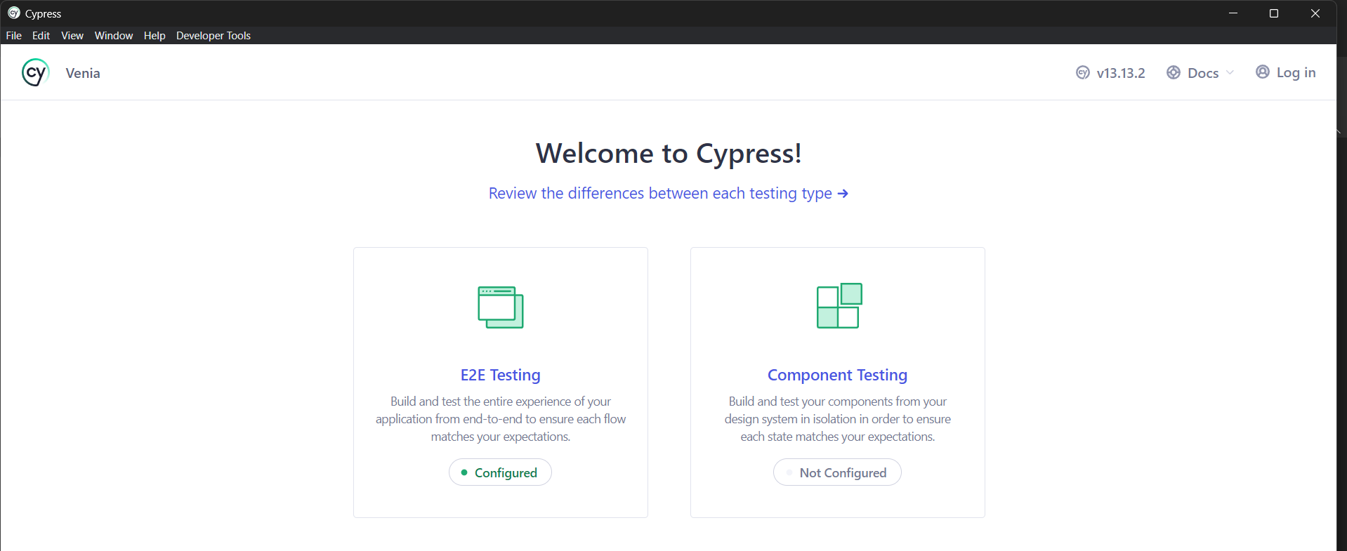

**Configure E2E Testing (Prerequisites NODE JS and IDE)**

**Choose your Browser for Testing**

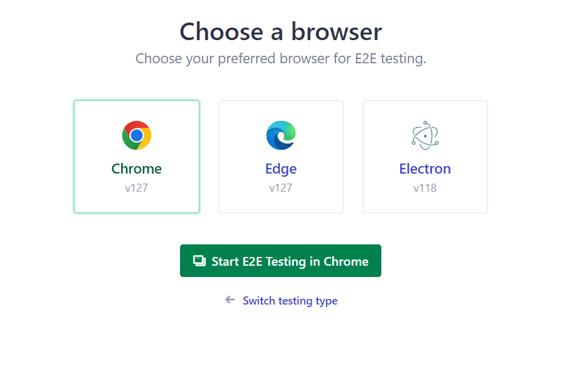

**Choose your Test Files to Test**

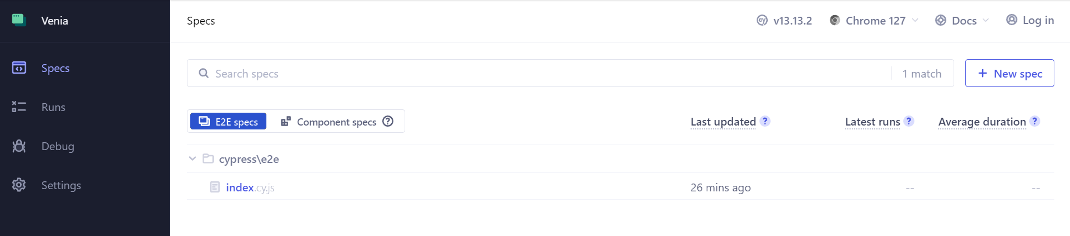

**Run the test by Reload/Refresh Button**

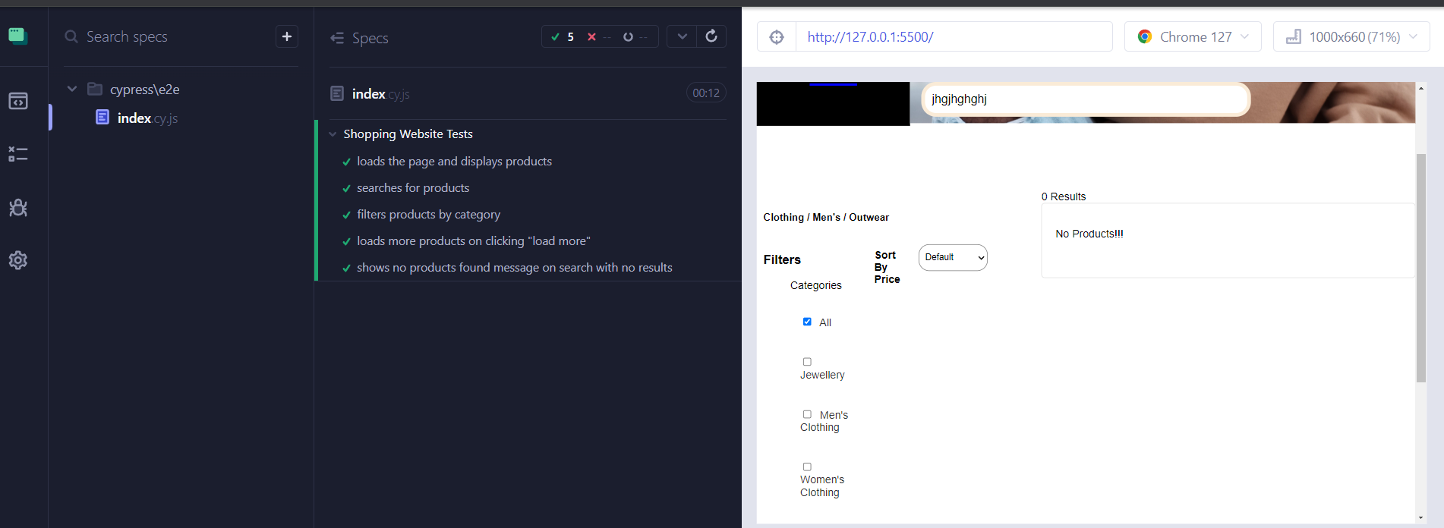

Or

**Run Cypress tests in the headless mode or use run button**

This will run all the tests in headless mode and output the results in the terminal.

**Step 5: Adding Cypress to Your CI/CD Pipeline (Optional)**

Add a script to your package.json to run Cypress it should look something like below

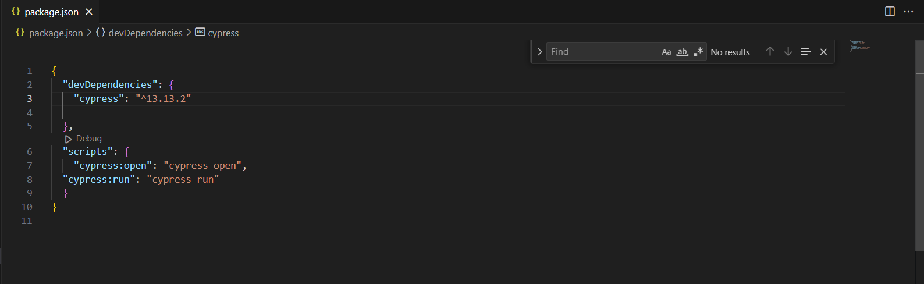

Run Cypress in your CI/CD pipeline:



By following these steps, you'll have Cypress installed and configured for your existing project, ready to use for end-to-end testing.

**For any more information regarding Cypress, check out the given link below:**

<https://docs.cypress.io/guides/overview/why-cypress>